Alex Arnold
Professor Torres
3-13-25
IT 120-41198
Lab 7

Part A:
Win2012:

Via command line or GUI, create a folder called shareit in the d:\\ directory
Via command line or GUI, locate all of your files, and move them to the shareit
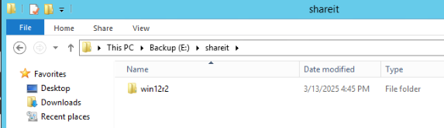
Folder created and files moved

Share the shareit file on the network using Windows File Sharing
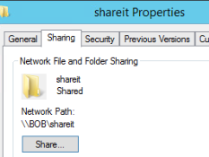
Folder shared
Configure auditing on shareit and test to ensure a log is generated when accessing. editing, or deleting anything
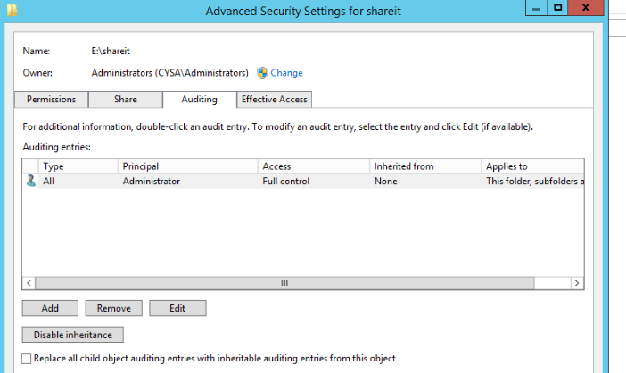
Auditing enabled on shareit
This is a domain controller (group policy). Run gpupdate /force to take effect.
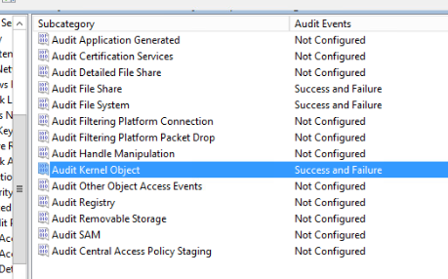
Auditing enabled
Kali:

Create a file called kalifiles in your /var/www/html directory via command line
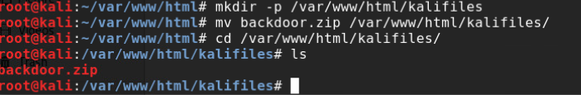
Find all files with the following extensions: .pcap, .exe, .msi, .py, .zip via Command line
Move files into backdoor via cli
- sudo find / -type f \( -name "*.pcap" -o -name "*.exe" -o -name "*.msi" -o -name "*.py" -o -name "*.zip" \) -exec mv {} ~/backdoor/ \;
Compress the files
- zip -r backdoor.zip backdoor/
Run the below command, go to your windows and download zip file
service apache2 start
Go back to Windows 2012r2 and download the files from http://192.168.1.3/kalifilesLinks to an external site. to shareit
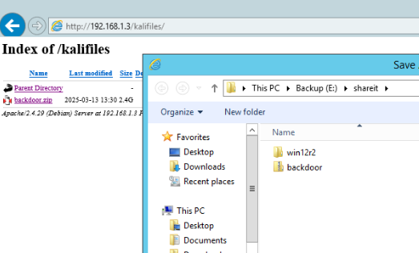
Files moved from kali
Delete kalifiles from kali
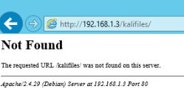

Winclient:

Copy all files from Documents to Toolbox on desktop
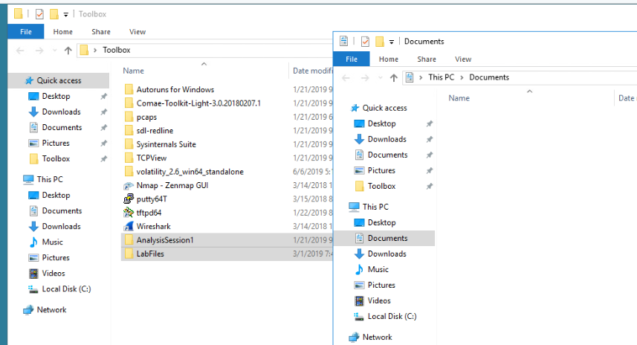
Files moved
Access file share of shareit from Windows 2012r2, and move Toolbox into shareit
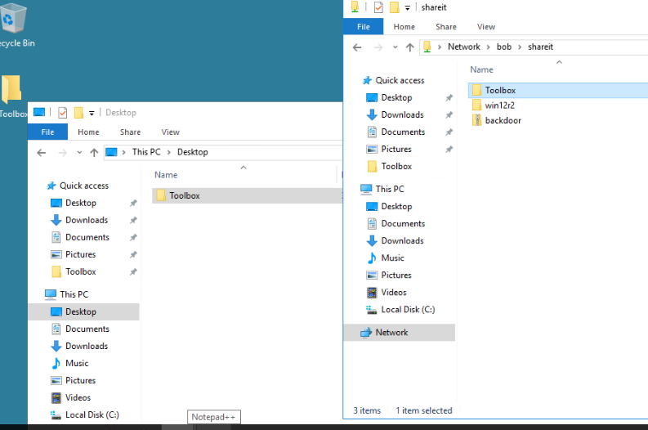
Files moved
Delete the Toolbox folder/files from winclient
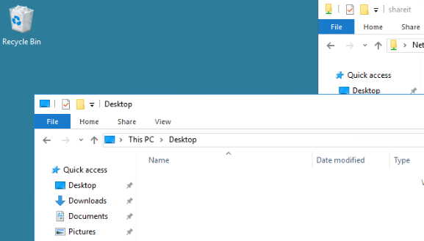
Toolbox deleted

Ubuntu:

Use GUI to centralize your files
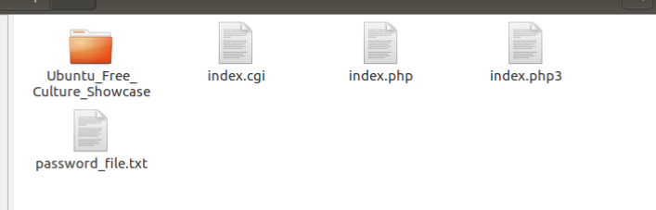
Files centralised
Access the windows file share and copy files into windows shareit
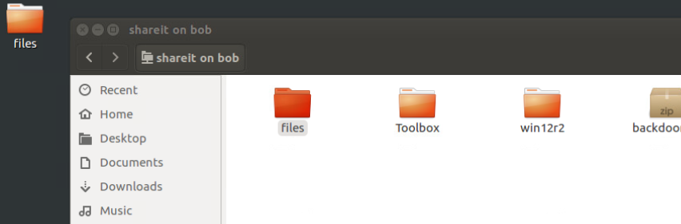
Files moved
Delete files from ubuntu
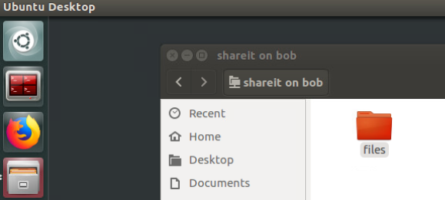
Files deleted

Part B:
Kiwi Syslog Server
Add "All" systems to the kiwi syslog server test
windows 2012 r2 --install forwarder from fileshare
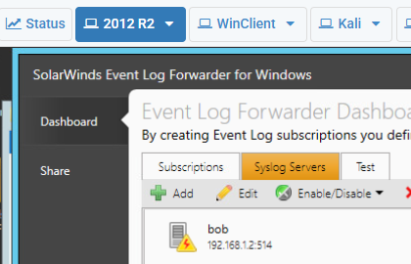
w12r2 setup
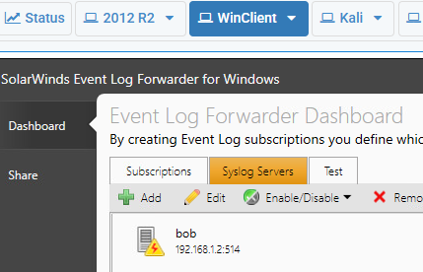
Winclient setup
Linux add to rsyslog.d file on Ubuntu and Kali: *.* @192.168.1.2:514

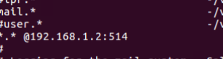
Ubuntu setup
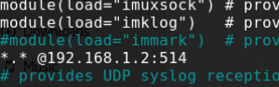
Kali setup
Make changes to your shared folder and monitor logs for events in the Kiwi Syslog application
Open your Kiwi Syslog server. You should see events flowing in.
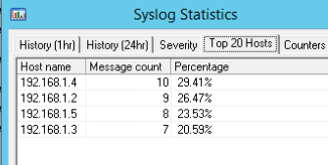
Make changes to Windows share drive, see triggered event to the kiwi Syslog Server
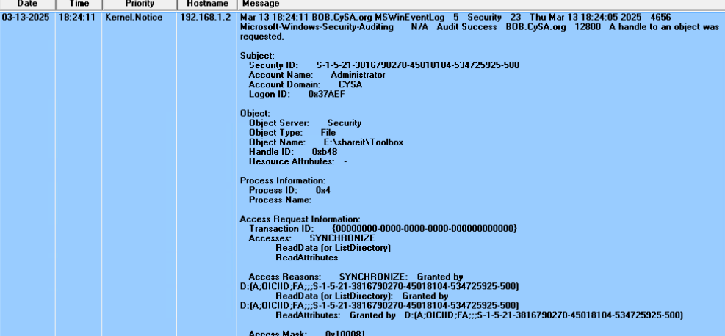
Change made to the share
Part C:
Discussion:

Discuss what you can do to make this process more efficient
This process can be made more efficient by having policy set to only allow user files to be stored in a shared folder. Another option is to have user drives that are automatically mapped to the system based on the user to have a centralized file storage. For the deployment of syslog and such you can use an image deployment software / group policy to deploy the syslog client and use scripts to automatically configure the settings for the logging. Using such tools will allow for a mostly automated deployment of the syslog / configuration and the group policy will prevent files from being stored all over the place.
Why is all of this important?
This is important as Data is the lifeblood and money of a company. If the data is not protected then the company could be in violation of things like HIPPA and other regulatory laws as well as the potential for data theft / insider sabotage and so on. Beyond the centralized storage you also need to have some form of monitoring as if there is no monitoring or alerts then there is no way to know there is an issue in the first place.

